**Family Check-Up**  **Assessment and Goal Setting**

®

**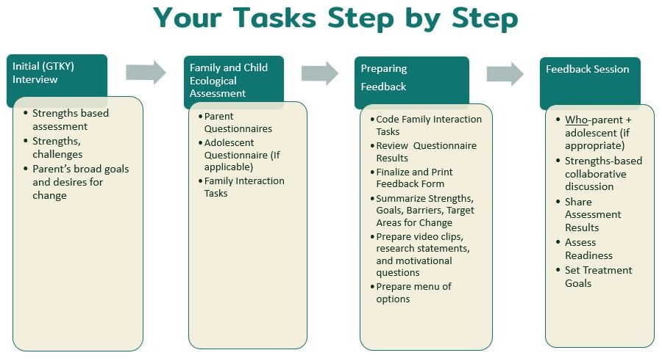**

# *Note: See the FCU Portal for relevant information, handouts referenced below, and instructional videos*

# INITIAL INTERVIEW

# Purpose: Initial interview is a strengths-based discussion, using spirit of Motivational Interviewing, in which you build rapport and engagement, elicit parenting family strengths and seek to understand parenting and family challenges and goals. Information gathered will inform final Feedback Form and Feedback Session with family.

# Tasks

# In advance of session

* + Clarify or decide which youth in the family will be the focus of the FCU process (more than one youth in family can be included, but typically just one is the focus)
  + Plan for ways to integrate Initial Interview process with agency’s typical agency intake process
  + Optional: review *Motivational Interviewing Tools* to prepare to use during session

**During session**

* + Review informed consent & obtain permission to record, for sessions and Family Interaction Tasks; recommended to raise discussion about recording interaction tasks after engagement has been built
  + If desired, reference *Outline of Initial Interview* before and/or during session as guide for steps below
    - Explain Family Check-Up process and answer questions
    - Gather information and build rapport
    - Listen for/elicit strengths
    - Listen for/elicit concerns
    - Listen for/elicit hopes, goals, and desire for things to be different for the youth and/or family
    - Summarize what you learned
    - Explain that interview is followed by assessment; schedule assessment/interaction tasks

## Supplies

* + Consent form and permission to record
  + Optional: Video recording device, if recording for supervision (e.g., cell phone, laptop, etc.)
  + Optional: [*Outline of Initial Interview*](https://thefamilycheckup.com/sites/default/files/2023-10/Outline%20of%20Initial%20Interview.docx)
  + Optional: [*Motivational Interviewing Tools*](https://thefamilycheckup.com/sites/default/files/2023-10/Motivational%20Interviewing%20Tools.docx)

## ASSESSMENT: QUESTIONNAIRES & FAMILY INTERACTION TASK (FIT) VIDEOS

# Purpose: The assessment process provides information about the family’s strengths and areas in need of improvement through standardized assessment procedures. The domains assessed, questionnaire items, and Family Interaction Task (FIT) scoring all were developed based on research about areas important to youth and parent healthy development and well-being.

# 

# Tasks

# In advance of session

* + Prepare questionnaires
    - Click on “Questionnaires” tab on FCU Portal, then click on “My Questionnaires”
    - Create all relevant questionnaires, copy links, and either set up questionnaires on your device in advance of session by pasting links in a tab in your browser, or email links to caregivers.

OR, if family needs to complete assessments offline, print questionnaires from Assessment section of FCU Portal

* + - * For youth ages 2-5: *CG Report on Family & Self* and *CG Report on 2-5*
      * For youth ages 6-10: *CG Report on Family & Self* and *CG Report on 6-10*
      * For youth ages 11-17: *CG Report on Family & Self*, *CG Report on 11-17*, *Youth Self Report 11-17*
  + Choose and print 3 or more FITs based on guidelines in age-appropriate *Family Interaction Task Script*
  + Review age-appropriate *Family Interaction Task Script* to identify materials needed for FITs

**During session**

* + Have parent complete questionnaires, if not completed between sessions (you may offer assistance)
  + If youth is 11-17 years old, have youth complete self-report questionnaire, if not completed between sessions (you may offer assistance)
  + Facilitate FITs
    - Set up toys or materials as needed
    - Set up and start video recording
      * NOTE: When recording via laptop, dim your screen so families can’t see themselves being recorded. When recording via tablet, flip the camera so the back of the tablet is facing the family, not the screen.
    - Read FIT script for each task you chose in advance
    - Remove yourself from setting or at least from view of the family (or hide yourself on screen if seeing family via zoom or other virtual platform)
    - Time each task
    - Do your best to not engage with family during and between tasks
  + Schedule a 60-minute Feedback Session to occur 1-2 weeks after the assessment is completed

**Supplies**

* + Device family can use to complete questionnaires, if they’ll do so during session (e.g., tablet, laptop, etc.)
  + Video recording device, likely the same as for questionnaires (e.g., cell phone, laptop, etc.)
  + Paper-pencil questionnaires if they’ll be used, found in the *Assessment* section of the FCU Portal, under [Paper-Pencil Questionnaires](https://thefamilycheckup.com/fcu/assessment" \l "paper_pencil_questionnaires)
  + Timer

**In advance of session**

* + Printed age-appropriate *Family Interaction Task Scripts,* in *Assessment* section, under [Family Interaction Tasks](https://thefamilycheckup.com/fcu/assessment#family_interaction_tasks)
  + Age-appropriate materials from *Family Interaction Task Scripts,* in *Assessment* section, under [Family Interaction Tasks,](https://thefamilycheckup.com/fcu/assessment#family_interaction_tasks) if needed for interaction tasks you’ve chosen
  + Optional: *[Creating and Using Online Questionnaires](https://thefamilycheckup.com/sites/default/files/Creating%20and%20Using%20Online%20Questionnaires.docx)*

# PREPARING FEEDBACK

# Purpose: The feedback preparation process is used to do the following, all through a parenting lens: summarize and integrate all information gathered from the family: identify themes related to strengths and areas for improvement; understand family members’ readiness to change in need areas; and brainstorm potential avenues and services to address needs areas in ways that leverage their strengths and match their readiness to change. This process prepares you to collaborate with caregivers in the Feedback Session.

# Tasks

* + Review and code FIT videos using age-appropriate *FIT Coding Manual*; if desired, track codes in *FIT Video Coding Form*
  + If questionnaires were completed via paper-pencil versions, enter questionnaire responses in *My Questionnaires* section of FCU Portal
  + **Create Final Feedback Form(s):** Review computer-generated questionnaire results, codes for FIT videos, and notes from Initial Interview and any other sources of information. Adjust teardrops on computer-generated results screen to capture all information gathered, using your clinical judgment and emphasizing strengths. Once teardrops are adjusted as needed, this will be your final Feedback Form to be shared in the Feedback Session.
    - * Download and print pdf of final Feedback Form
      * If there is more than one caregiver, or an adolescent who completed the self-report questionnaires, repeat the steps above for them, to create additional Feedback Forms, i.e., one per person
  + **Take notes to prepare for Feedback Session:** Follow top section of *FCU Feedback Prep Worksheet* as guide for summarizing assessment information, including readiness to change. (This form is designed for you to summarize and take notes for yourself)
    - * Identify key themes: strengths and areas of concern to emphasize at Feedback Session (i.e., where beneficial change could happen, and strengths could be leveraged)
      * Follow outline in bottom section of *FCU Feedback Prep Worksheet* to prepare video clips, any research kernels, motivational questions, menu of options, etc., that you will have ready to talk about during the Feedback Session.
  + IF DESIRED, transfer points/teardrops from downloaded pdf of final Feedback Form to a blank age-appropriate *Feedback Form* (e.g., if you want to add an item in the “other” row; if you want to put all points on one page and make it visually easier to absorb when this would be helpful to parent; etc.)

**Supplies**

* + Notes from Initial Interview and any additional info, such as info from agency intake
  + Videos of FITs completed by the family
  + Age-appropriate *FIT coding manual,* found in *Assessment* section of FCU Portal, under [Family Interaction Tasks](https://thefamilycheckup.com/fcu/assessment" \l "family_interaction_tasks)
  + Optional: *[FIT Video Coding Form](https://new.thefamilycheckup.com/sites/default/files/FIT%20Video%20Coding%20Form.docx)*
  + Computer-generated questionnaire results for the family, from the *My Questionnaires* section of FCU Portal
  + *[FCU Feedback Prep Worksheet](https://thefamilycheckup.com/sites/default/files/FCU%20Feedback%20Prep%20Worksheet.docx)*
  + Optional: Blank age-appropriate *Feedback Form*, found in Feedback section on FCU Portal, under Feedback: [Implementation Materials](https://thefamilycheckup.com/fcu/feedback#implementation_materials)
  + Optional: [*Summary of Research*](https://new.thefamilycheckup.com/sites/default/files/2022-11/Summary%20of%20Research%20(English).pdf)
  + Optional: *[Motivational Interviewing Tools](https://thefamilycheckup.com/sites/default/files/Motivational%20Interviewing%20Tools.docx)*

# FEEDBACK SESSION

# Purpose: The feedback session is used to consider and expand assessment of family strengths and need areas collaboratively with family and to set goals. You will focus on strengths and facilitate parents’ motivation to change in areas of need through your use of MI tools, using the information you prepared with *FCU Feedback Prep Worksheet.* The ultimate goal of session is to facilitate parents’ self-reflection and creation of goals in areas in which they choose to change and grow in parenting and managing their family.

# Tasks

* + Recommended: reference *FCU Feedback Session Outline* before or during session as guide for completing steps below
    - Explain feedback process
    - Invite parent self-assessment
    - Explain *Feedback Form* using blank form
    - Discuss feedback, integrating FIT video clips, and possibly research kernels and MI questions
    - Provide summary and highlights
    - Collaboratively set parenting and family management goals, referencing menu of options, and write goals in Goals Form

**Supplies**

* + A device on which to show video clips from the FITs
  + Optional: video recording device, likely same as above (if recording for supervision or for certification)
  + Optional: [*FCU Feedback Session Outline*](https://thefamilycheckup.com/sites/default/files/FCU%20Feedback%20Session%20Outline.docx)
  + Blank *Feedback Form* for relevant age group, found in *Feedback:* section on FCU Portal, under Feedback: [Implementation Materials](https://thefamilycheckup.com/fcu/feedback#implementation_materials)
  + Completed Feedback Form that you downloaded from *My Questionnaires* section of FCU Portal
  + Blank [*Goals Form*](https://new.thefamilycheckup.com/sites/default/files/8-Goals%20Form%20%28English%29.docx) *-* English
  + Blank [*Goals Form*](https://new.thefamilycheckup.com/sites/default/files/9-Goals%20Form%20%28Spanish%29.docx) - Spanish
  + Optional: [*Motivational Interviewing Tools*](https://thefamilycheckup.com/sites/default/files/Motivational%20Interviewing%20Tools.docx)