Overview of Key Web-Based Resources - For New FCU Staff

This document is designed to be used by staff who are just beginning their training in Family Check-Up model.

It outlines each of the key web-based resources you will use as you learn and implement the Family Check-Up model. As soon as you’re set up on each site, please save each link into your favorites or bookmarks, ideally with your log-in info saved, too.

The FCU Portal homepage (thefamilycheckup.com) contains four buttons that can be used to access resources related to implementation of the Family Check-Up®:
- The Family Check-Up Resources Portal
- Family Check-Up Online
- Access to Family Check-Up eLearning, via ASU CareerCatalyst Homepage
- Northwest Prevention Science Website

If you encounter any difficulty accessing or using one of the resources listed above, please contact psalm@nwpreventionscience.org.

The portal homepage will look like this if you click ‘Family Check-Up' on the left corner of the screen or are not logged into the Portal:

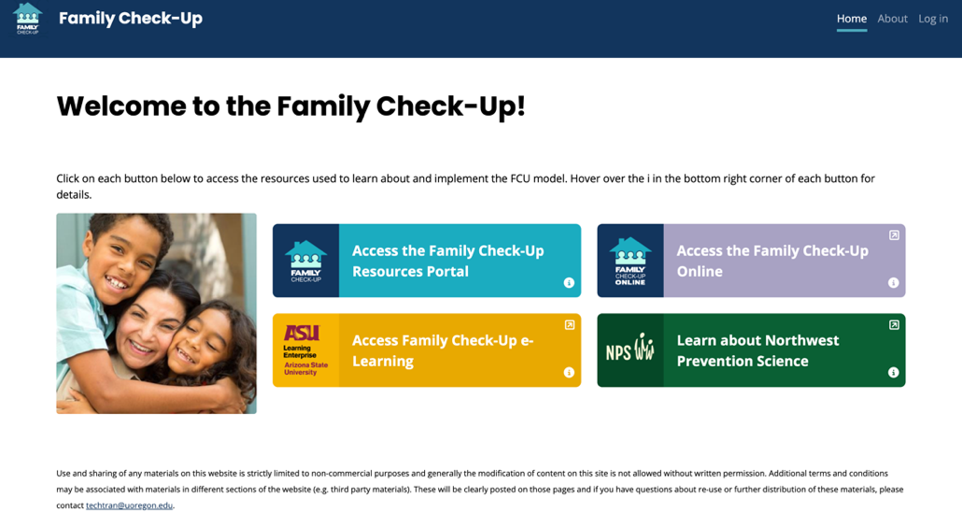

- Family Check-Up Resources Portal
  - All trainees receive access to the the Family Check-Up (FCU) Resource Portal.
  - Trainees will first receive access to the portal through an email invitation from an FCU no-reply email.
  - The portal access email link will take you to a page that looks like this (your email in place of the email in the first line):

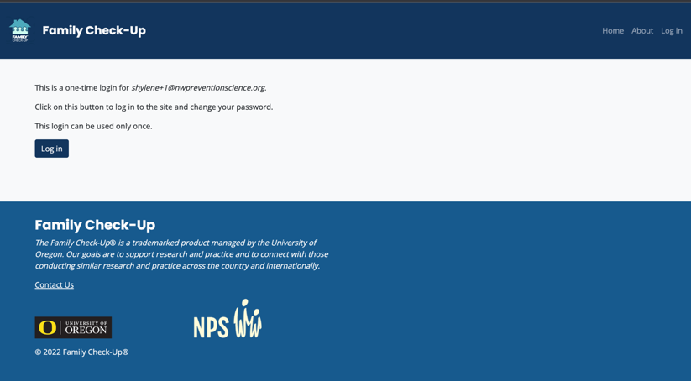

  - When clicking on the log in above, you will be prompted to change your password. Once you do so, you can then access the FCU Portal.
  - All resources necessary to deliver the Family Check-Up program to caregivers and families are available through the FCU Portal.
  - You will receive training regarding accessing and using the materials in the portal during the webinar trainings.
  - The FCU Portal is also used by candidates for Certification as a Supervisor-Trainer. There is a Supervisor-Trainer tab with additional materials available only to Supervisor-Trainers
  - Trainees should explore the FCU Portal prior to attending the first FCU webinar.

- The Family Check-Up Online® (This resource is a digital adaptation of the Family Check-Up available to agencies who choose to subscribe to it.)
  - Family Check-Up Online (FCU Online) is a web-based application for caregivers that can be accessed asynchronously via the internet, including from mobile devices.
  - The program includes brief assessments, auto-generated feedback, and intervention modules
  - For agencies that have contracted to offer FCU Online as a resource for caregivers, trainees will receive access to the FCU Online dashboard. The dashboard provides access to information about caregivers’ use of the app. See this link for additional information.

- eLearning Courses
  - Your initial training in the Family Check-Up model, including the Family Check-Up (FCU) and Everyday Parenting (EDP) components, occurs via two eLearning courses offered by Arizona State University (ASU) CareerCatalyst.
  - Northwest Prevention Science (NPS) provides discounted eLearning access to trainees as a part of any implementation project
  - Trainees are responsible for completing their Family Check-Up eLearning course before attending the FCU webinar training and for completing the Everyday Parenting eLearning course before attending the EDP webinar training.
  - NPS will provide the agency with eLearning progress updates about each trainee prior to the webinars.
  - Click this link for a walkthrough video of registering for your eLearning courses: Registering for CareerCatalyst FCU eLearning Courses.mp4
  - Trainees receive access to eLearning in an ‘eLearning Access Instructions’ email from NPS that provides a link to sign up for your eLearning courses.
  - The CareerCatalyst homepage will look like this:
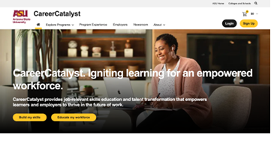
  - Trainees are sent a specific link to your course bundle that will look similar to this:

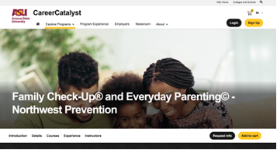

  - After registration, trainees will be redirected to a web-based learning management system called Canvas. This is where you will be working through course modules.
  - Viewing a course on Canvas will look like this: 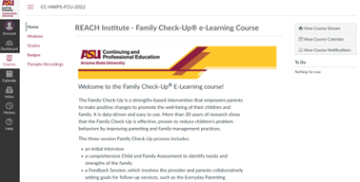

- Northwest Prevention Science (NPS) Website
  - The NPS website is dedicated to information relating to the Northwest Prevention Science team and Family Check-Up
  - Provides a brief overview of Family Check-Up and Family Check-Up Online, as well as other general resources relevant to training and implementation
  - Introduces team members and provides a way to contact the NPS team with training and implementation inquiries

